ALAGAPPA GOVT. ARTS COLLEGE
KARAIKUDI – 630 003



NANMUDHALVAN PROJECT

PROJECT NAME : A DATA – DRIVEN EXPLORATION OF APPLE’S IPHONE IMPACT IN INDIA

IREVOLATION: A DATA- DRIVEN EXPLORATION OF APPLE’S IPHONE IMPACT IN INDIA

INTRODUCTION:
OVERVIEW:
Apple’s Presence in India can have both positive and negative impact on our country. While Apple’s presence in India can have positive impact such as job creation, economic growth, and technology transfer, it also has potential negative impacts such as increased competition for local companies and environmental concerns.

PURPOSE:
  - Control accessories in your home.
  - Combining mobile telephone.
  - Digital camera, music player , and personal computing technologies.
MILESTONE 1:
PROBLEM DEFINITION AND DESAIGN THINKING:
EMPATHY MAP:
https://github.com/asaluau0121bma0528/A-Data-Driven-Exploration-of-Apple-s-Iphone-Impact-In-India_NM2023TMID26769/blob/main/empathy%20map%20in%20naan%20mudhalvan.pdf

BRAIN STORMING: 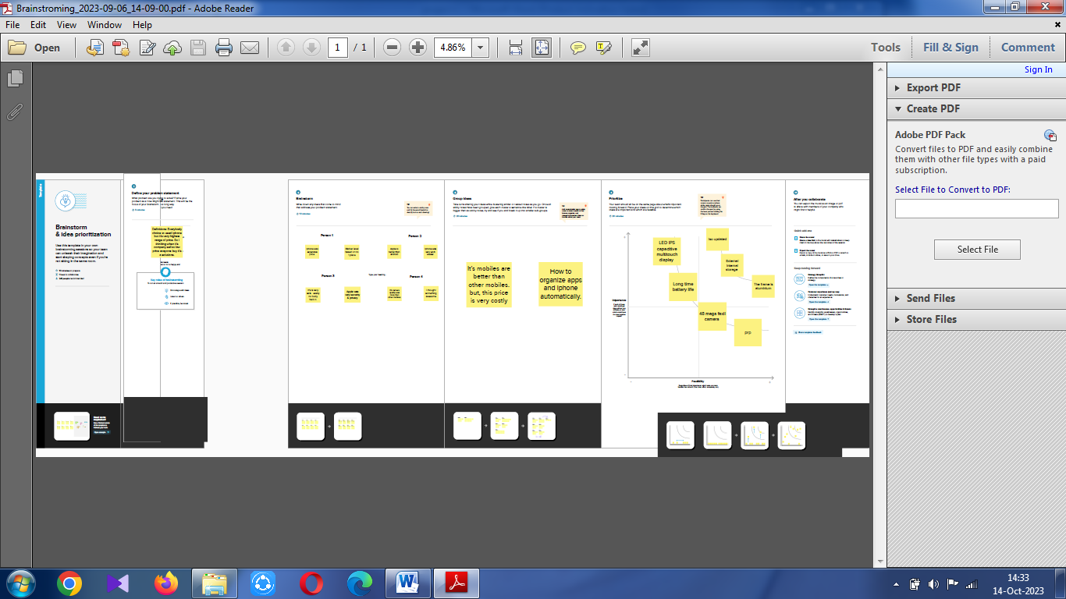
https://github.com/asaluau0121bma0528/A-Data-Driven-Exploration-of-Apple-s-Iphone-Impact-In-India_NM2023TMID26769/blob/main/Brainstroming_2023-09-05_09-03-13.pdf

RESULT:
Apple has a massive and loyal customer base that is willing to pay a premium for its products . The company has built a reputation for quality, reliability, and customer service, which has led to a high level of customer satisfaction.
MILESTONE 2:
DATA COLLECTION AND PERPARISON:
ACTIVITY 1:
COLLECT THE DATASET:
Please use the link to download the dataset: link
ACTIVITY 1.1: Understand the data
Data contain all the meta information regarding the column described in the CSV files. We have provided the XLX file:
COLUMN DESCRIPTION FOR BIGML_DATASET.CSV:
The file apple_ products xlsx contain a total of 7 sheet . each sheet correspond in to a different parameter related to iphone /smartphone.

THE SHEET ARE:

Connect the dataset in the Tableau.com
- Apple_products.csv
- Flipcart _ smartphone
- Annual revenue
- Market penetration (iphone)
- Country wise share
- Quarterly-share
- Model –wise share
ACTIVITY 2:
CONNECT DATASET WITH TABLEAU
Reference video link:
https://drive.google/file/d/1JSsNhUUhY4Cq1u0b0FKC40jz6LAa1ylc/viwe?usp=sharing

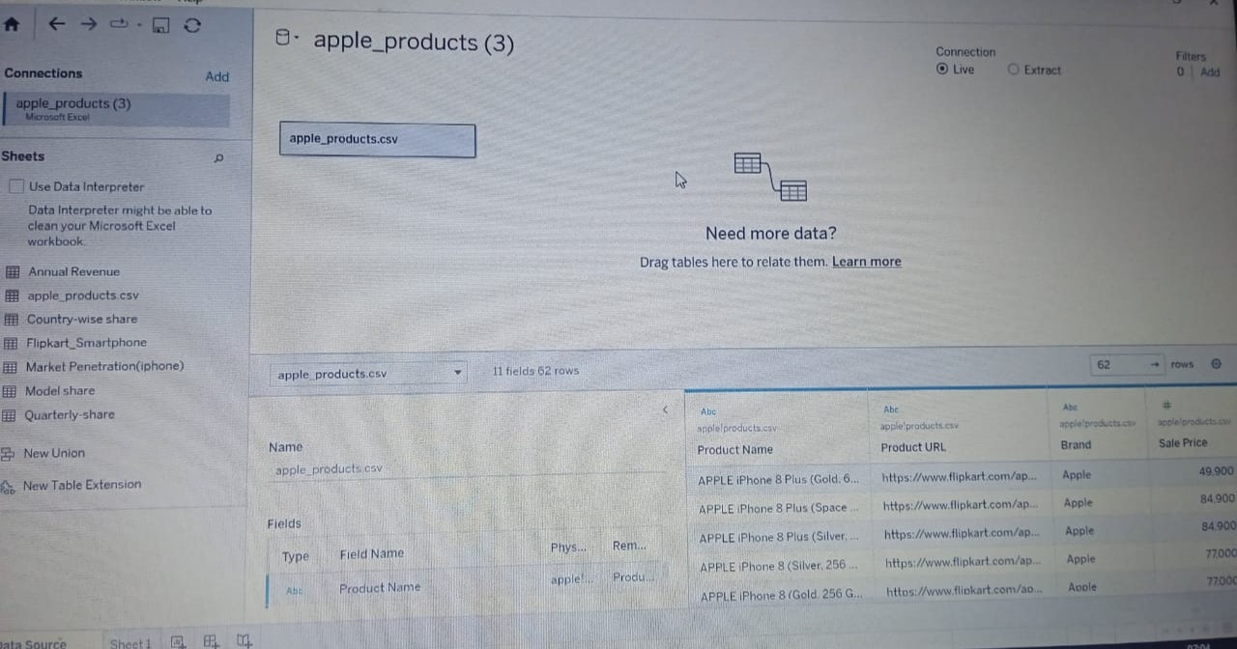

MILESTONE 3:
DATA PERPARISION:
Data modules are containers that describe data and rules for combining and shaping data to prepare it for analysis and visualization in tableau. Data module sources. Data modules can be based on servers, package, uploaded files ,datasets, and other data modules.

MILESTONE 4:
DATA VISULIZATION:
Data visualization is the process of creating graphical representation of data in order to help people understand and explore the information.
ACIVITY 1:No of unique visualizations.
The number of unique visualizations that can be create with a given dataset.

ACTIVITY1.1:
Create The Graph On The Tableau Book 1
KPI 1
Go to your data select apple product and Go to your sheet 1 the data will be appear.
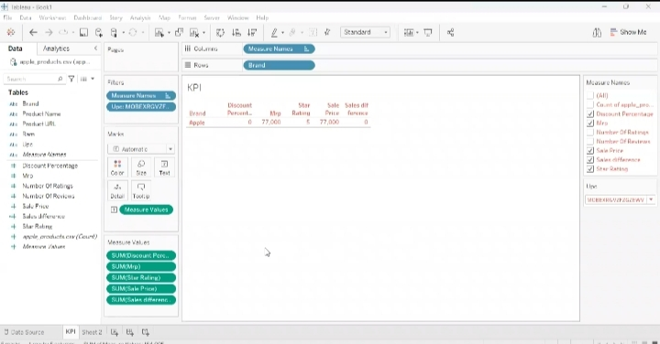
- Click on the sheet 1 the page will be appear.
- Click the brand and drag into X-axis.
- Then click the measure name in Y-axis.
- Make a filters in measure values, colours and label in the filter box.
- Then drag the SUM (mrp),SUM (sales price), SUM( star rating), SUM (sales difference), SUM (discount percentage).
- Then finally the values are appear in the sheet .
- Finally save the graph KPI 1 in the Tableau.
- Click the save as in the file option and save the graph.

ACTIVITY 1.2:
Again go to your data and you can select the deside sheet flipcart smartphone, you can see the data in the sheet and go to sheet 2.
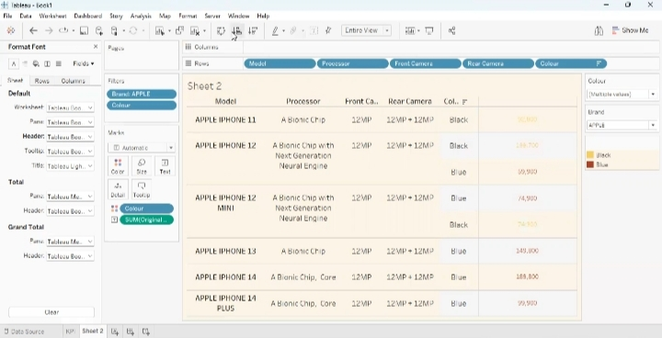
- Click model and drag into the X- axis .
- Then drag the processor into the X- axis, Front camera, Rear camera and you can go for colour.
- You can add filter according your brand and choose apple click on all and apply click ok.
- Then you can colour option keep all for click ok and apply. You can add colour so that SUM(original price) in Label, price appear in the graph complete information in the particular Model, Brand.
- Click the Brand , show the filter go for single value dropdown click apple the changes will appear go for standed view.
- You can go for colour and change the colour your choose.
- Then go for format option workbook will appear change the grid line, size.
- Then right click on the format option you can see various options label, size, fount size change your choose.
- Then finally save the changes in the workbook ,click save as and save Model specification.

ACTIVITY 1.3:
BATTERY TYPE :
Again go for your dataset and connect the flipcart smartphone data and go to your sheet 3.
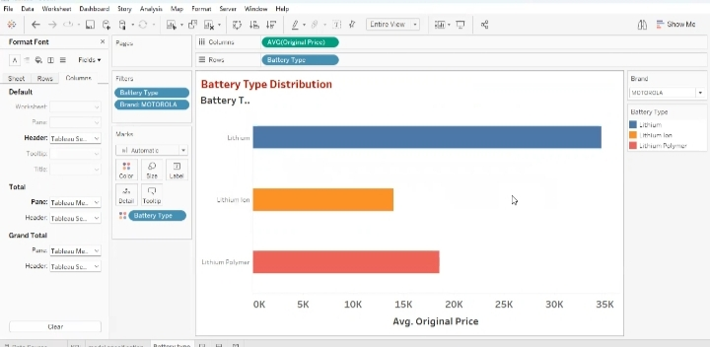
- Click the tittle change the colour, size , fount and increase or descrease the size click ok then apply.
- Now I wish to drag the battery type distribution in the X-axis ,values are appear in the graph.
- Now deselect the null option from the filter and see the original price in the battery type.
- Now see the particular brand ,select the any brand and click apply.
- Go for single value dropdown and you can select any value, I select Motorola now see the values will change and this is the original price and for average.
- Next step being your creativity.
- Finally save your workbook ,click save as and save .

ACTIVITY 1.4:
BRAND PRICE COMPARISSION:
Already the dataset will connect in the flipcart smartphone is same as .
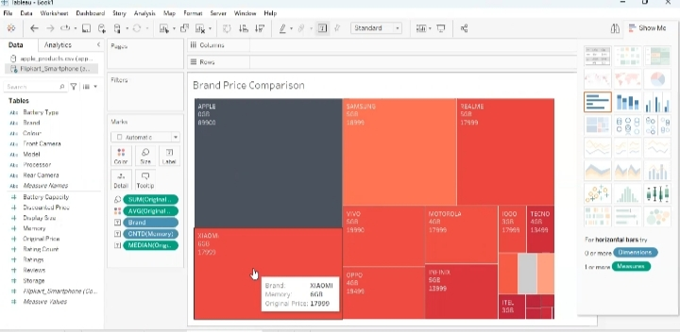
- First drag the brand and price to compare X-&Y-axis. And you can change the columns & rows for the Table option .
- Then filters are show in SUM(original price),in colour &Brand in label.
- Now with in label what I shoe this already brand is show in the label other then brand show its memory and go for discreat & distinct card .
- Then go for original price the steps will again SUM(average) right click on the average format option will appear, change the num, alignment, prefix are suffix.
- Instant of average are will appear in the graph.
- Again you can edit the colour , change any deside colour.
- The next step is our creativity .
- Finally save our changes in our workbook click save as and save.

ACTIVITY 1.5:
MODLE SHARE:
Again for your dataset and connect Model share ,see various of icons are show in the dataset and go for your sheet.
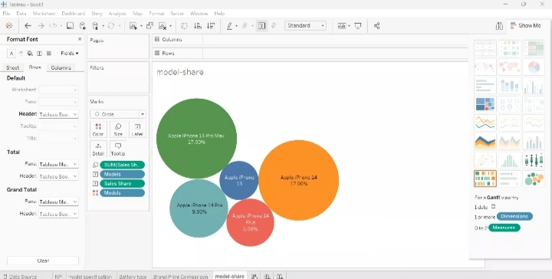

- Click &drag the models on X-axis and sales price in Y-axis.
- We can go for bubble chat ,means of bubble chat is according to the size of the share it will increase or decrease the shape of the share instant of circle we can go for shape &choose circle.
- Model wise also select any other colour & click ok.
- Then drag the sales share in label.
- Instant of sum of sales share go for dimension .
- Now go an format option go to axis then costom 1& you can change the number of decimals to percentage.
- Finally save the changes in the workbook click save as & save.

ACTIVITY 1.6:
COUNTRY WISE BEST SELLING SMARTPHONE:
Go to our dataset and connect the country wise share ,see all the country what kind of smartphone selling (USA, INDIA,UK, ect…). Go to your sheet.

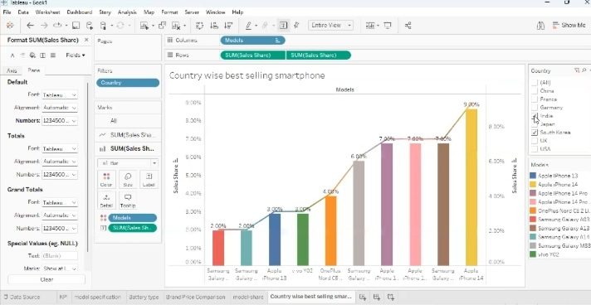
- Drag model in columns then sales share in rows .
- What we can do this filter in country wise select india and click ok.
- Right click the format option go to gridlines none .
- Remove this first price column and click on entire view, show filter then increase &decrease the size on the graph.
- Drag the models in colour .now create a line bar chat range it assiending wise and do is control drag it two type of bar chart appear.
- Click on any one price and see the brand, model, size ,version.
- We can already on bar and change the line chart &see this now complain right click to marge the chart .
- Go to Labels and show the price on each country wise selling.
- Next step is our creativity .
- Finally save the workbook.

ACTIVITY 1.7:
QUARTERLY-SHARE:
Again go to our data set add the quarterly share double click and connect see here Q1, Q2, Q3, Q4. From 2017-2022 data for each Quarter. Go to our sheet.
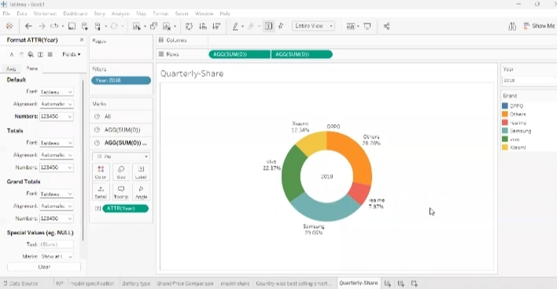
- Creat one calculated field annual share.
- Click & drag the brand in colour, annual share in sum click entire view.
- Now I want brand in colour and annual share in label .
- Percentage will see in the graph.
- Q1 ,Q2, Q3,Q4 go to format in percentage label.
- Rows in sum 0 press control and drag it same in share . two bie chart will creat.
- Change the colour something do this in label.
- Next is our creativity .
- Finally save our workbook.

ACTIVITY 1.8:
ANNUAL REVENU:
Go to our datasets add the annual revenue data see all the annual revenue of smartphone & go for our sheet.
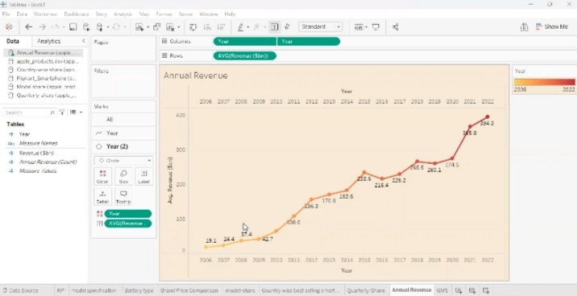
- Drag the revenue in rows and year in columns and right click the format option change the grid lines in very small.
- Make ever think none.
- Then year wise annual share is making .
- Now click control and press year I drag it in same columns .
- First one is making a line it and change in chart, 2nd one is change in circle.
- Then change in usual chart.
- Decrease the size as both.
- Year in colour and change the different types of colour.
- Again right click the dual axis the annual revenue show on it .
- Finally save our workbook.

ACTIVITY 1.9:
GLOBAL MARKET SHARE:
Again add the dataset in country wise share and connect the set .you to see latitude and longitude are in generated.
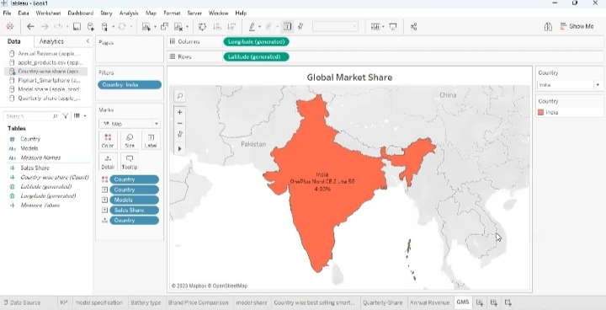
- Drag in the latitude in rows and longitude in columns.
- You can take any other map in filters .
- Now country in colour difference between these two.
- Filter it click on india click ok and apply they will be show.
- We get a single value drop down drag in label .
- Then model can be label &sales share as dimension.
- Go to format make it as percentage.
- Next is our creativity .
- Finally save your workbook.

ACTIVITY 1.10:
KPI 2:
Again go to add a dataset market penetration (iphone),basically particularly revenue generated and the abtibuces of the iphone . go back for our sheet.
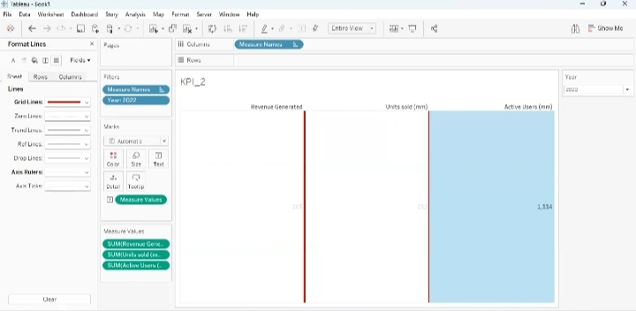

- Drag the units sold in column & revenue generated is same column and active users.
- Change KPI format .
- Now I want it filter in it year click ok and apply.
- Go for discrete click on particular year and click ok.
- Go for show filter make it a single value drop down .
- I can shift it unit sold in above, then abtibuces .
- We can have go for entire view craet the table view .
- Next is your creativity.
- Finally save your workbook.

MILESTONE 5:
DASHBOARD:
A dashboard is a graphical user interface (GU1) that display information and data in an organized , easy-to-read format . dashboards are often used to provide real-time monitoring and analysis of data, and are typically designed for a specific purpose or use case. Dashboard can be used in a variety of settings, such as business, finance, manufacturing, healthcare, and many other industries. they can be used to track key performing indicators (KPIs), monitor performance metrics, and display data in the form of charts, graphs, and tables .
ACTIVITY 1:
DASHBOARD 1:
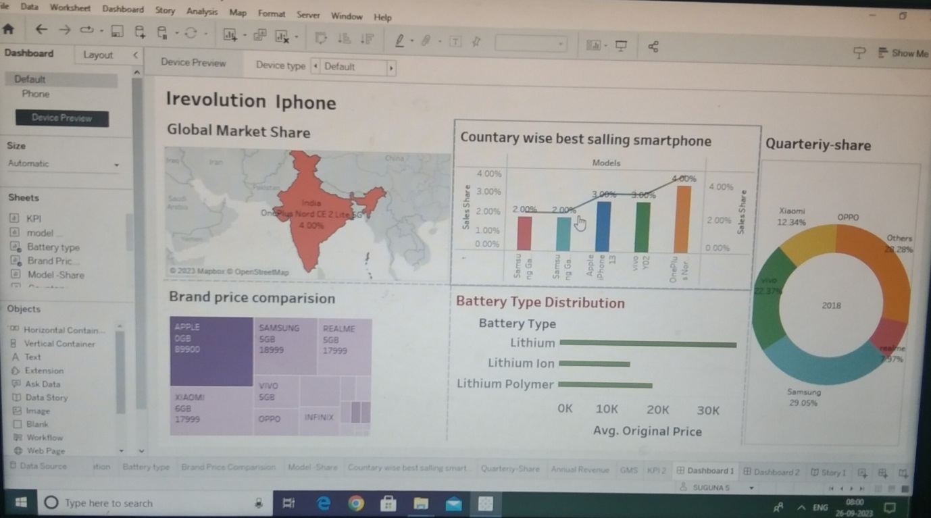

- Drag all the graphs in the dashboard first five sheet in 1.
- https://public.tableau.com/app/profile/Tamilmaniproject1......./Dashboard1?:language=en-us&publish=yes

DASHBOARD 2:

- Drag the remaining sheet in dashboard 2.

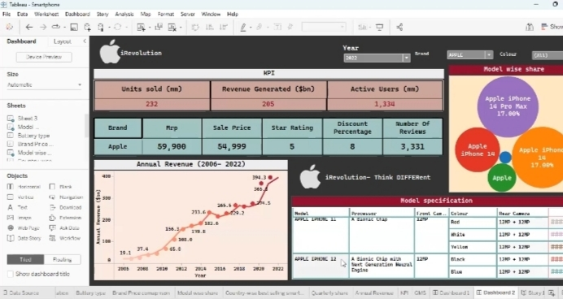
https://public.tablea.com/views/Tamilmaniproject1......../Dashboard2?:language=en-us&publish-yes

MILESTONE 6:
STORY:
A data story is a way of presenting data and analysis in a narrative format , with the goal of making the information more engaging and easier to understand .A data story typically includes a clear introduction that sets the stage and explains the context for the data , a body that presence the data and analysis in a logical and systematic way, and a conclusion that summarizes that key findings and highlights their implication. data stories can be told using a variety of mediums, such as report, presentation, interactive visualization , and videos.
STORY 1:
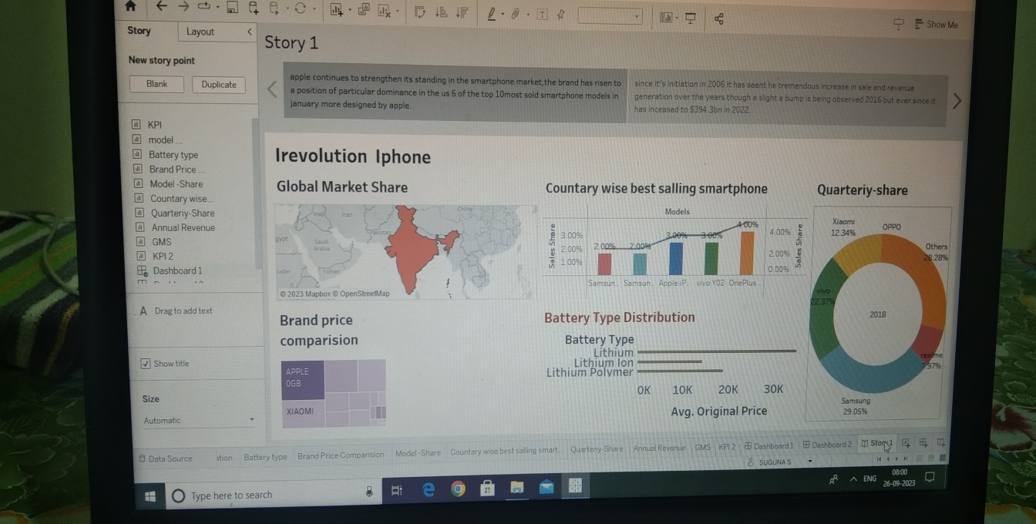
https:/public.tableau.com/views/Tamilmaniproject________/story1?:language=en-us&publish=yes

MILESTONE 7:
PERFORMATION TESTING:
ACTIVITY 1: Utilization of filters.

ACTIVITY 2: No of calculation fields

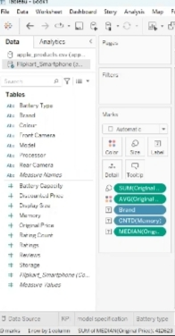
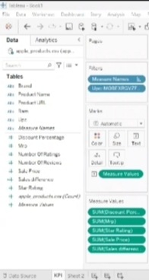
ACTIVITY 3:No of visualizations l groups
- KPI
- Model specification
- Model –wise share
- Battery –type distribution
- Brand – price comparison
- Country – wise best – selling smartphone
- Annual revenue year-wise
- KPI-2
- Global market share

MILESTONE 8:
PUBLISHING URL LINK:
Team Leader : https://pablic.tablrau.com/app/profile/suguna.s2876/viz/sugunsproject1/Dashboard1?publish=yes
https://public.tableau.com/app/profile/suguns.s2876/viz/sugunsproject1_/dashboard2?publish=yes
https://public.tableau.com/app/profile/suguna.s2876/viz/sugunaproject1___/story1?publish=yes
Team member 1: https://public.tableau.com/app/profile/Tamilmaniproject1......./Dashboard1?:language=en-us&publish=yes
https://public.tablea.com/views/Tamilmaniproject1......../Dashboard2?:language=en-us&publish-yes
https:/public.tableau.com/views/Tamilmaniproject________/story1?:language=en-us&publish=yes
Team member 2: https://public.tableau.com/views/sugapriyaproject__/dashboard1?:language=en-US&publish=yes
https://public.tableau.com/views/sugapriyaproject1___/dashboard2?:lnguage=en-US&publish=yes
https://public.tableau.com/views/sugapriyaproject1____/story1?:language=en-US&publish=yes
Team member 3: https://public.tableau.com/views/app/profile/priyanka.arasu/viz/dashboard1_1696322234260/dashboard1?publish=yes
https://public.tableau.com/app/profile/priyanka.arasu/viz/dashboard2___1696322234260/dashboard2?publish=yes
https://public.tableau.com/app/profile/priyanka.arasu/viz/story1-___1696322234260/story1?publish=yes

ADVANTAGES OF IPONES:
- User – Friendly interface
- High – Quality display
- Advanced Camera
- Apps Ecosystem
- Seamless integration with other apple devices
- Timely OS Update
- Better Performance
- Security and Privacy
- Third – Party App Security
- No Bloatware

DISADVANTAGE OF IPHONE:
- Cost
- Non-Removable Battery
- Limited Customization
- No Expandable storage
- Iphone don’t come with a headphone jack
- Iphones Have Fixed Storage
- Iphone Apple Take Up Too Much Space
- Iphone Have No FM Radio Built – In
- Iphone Accessories are Expensive
- Iphone have short battery life

MILESTONE 9:
PROJECT DEMONSTRATION & DOCUMENTATION
ACTIVITY 1:
Record explanation video for project end to solution.
ACTIVITY 2:
Project documentation-step by step project development procedure.
Create a document as per the template provided.
LINK:

CONCLUSION:
Conclusion of apple and the ipones it is apparent that the iphone was, and still, a remarkable invention of technological advancement. The ipones provided a new way of mobile phone communication and usability. its revolutionary technology has led to the variety of smartphones that are in use today.

